Planning Sheet for Single Science Lesson | Lesson Title: Bernoulli’s Principle (Part 1 – Activity Stations) | Cluster: 2 S.L.O: 6-2-06  Grade: 6

 | Teaching – Learning Sequence | Materials Required
- Cluster 0: Scientific Inquiry  Initiating, Researching & Planning  6-0-1a Formulate specific questions that lead to investigations. Include: rephrase questions to a testable form; focus research questions.  6-0-3a Formulate a prediction/hypothesis that identifies a cause and effect relationship.  Implementing; Observing, Measuring &  Recording  6-0-4c Work cooperatively with group members to carry out a plan, and troubleshoot problems as they  6-0-4d Assume various roles to achieve group goals.  6-0-4e Use tools and materials in a manner that ensures personal safety and the safety of others.  6-0-5a Make observations that are relevant to a specific question.  6-0-5f Record and organize observations in a variety of ways.  Analyzing & Interpreting  Concluding & Applying  6-0-7a Draw a conclusion that explains investigation results.  6-0-7b Base conclusions on evidence rather than preconceived ideas or hunches  6-0-7f Reflect on prior knowledge and experiences to construct new understanding, and apply this new knowledge in other contexts.  6-0-7g Communicate methods, results, conclusions, and new knowledge in a variety of ways. Examples: oral, written, multimedia presentations… | Summary:  - Introduce Bernoulli’s Principle by means of a class demonstration, followed by investigation station activities.  1. Class Demonstration:  - Affix 1 Styrofoam ball to a straw (glue, tape, etc…) and repeat process. Mount each unit in the up right position (Styrofoam balls supported on top of the straws) approximately 10cm apart.  - Have students:  - Predict what will happen to the Styrofoam balls if they blow air from a hairdryer directly down on the apparatus (The balls will move closer together).  - Blow air from the hairdryer (downward angle) between the two Styrofoam balls and observe what happens (Blowing air on the Styrofoam balls speeds up the air in between the Styrofoam balls and lowers the air pressure; therefore, the greater air pressure on the outer regions of the Styrofoam balls forces the balls together.  - Discuss the results and develop an explanation using the terms air speed and air pressure.  2. Activity Stations:  - Organize students into six groups of 3 (4)  - Assign roles:  1) Material/Resource Collector  2) Task Master (Keeps the group on task)  3) Time Manager (Keeps the group on time)  4) Chart Manager (Correct/accurate information)  - Indicate to students that they will be assessed on:  i. listening skills  ii. speaking skills  iii. group cooperation  iv. staying on task  - Have the Material/Resource Collector from each group retrieve and set-up the appropriate materials for their group station activity.  - Students will follow the outlined procedures for each activity in order to conduct and record investigation activities into their scientific method journals. (Students will rotate from station to station.) | - Overhead Projector  - White/blackboard  - Styrofoam balls  - Ping-Pong balls  - Straws  - Rulers  - String  - Hairdryer  - Funnels  - Paper index cards  - Eggcup holders  - Paper strips  - Activity Procedure Sheets (Please see: Appendix #1)  - Activity Description Sheet (Please see: Appendix #2)  Safety and/or Ethical Considerations:  - For hygienic safety, ensure that the funnels are washed with soap and water after each use by each student.  - Use tools and materials in a manner that ensures personal safety and the safety of others.
B.STSE Issues/ Design Process/ Decision Making  6-0-8c Recognize that technology is a way of solving problems in response to human needs.  6-0-9c Demonstrate confidence in their ability to carry out investigations.  Essential Science Knowledge Summary  In this lesson students will be taught that  C2. demonstrate appropriate scientific inquiry skills when seeking answers to questions  C3. demonstrate appropriate problem-solving skills while seeking solutions to technological challenges  D3. Understand essential life structures and processes pertaining to a wide variety of organisms, including humans.  D4. Understand how stability, motion, forces, and energy transfers and transformations play a role in a wide range of natural and constructed contexts  Assessment:  Assessment will be measured/ monitored as followed:  - (5 marks)Group work, including:  i. listening skills  ii. speaking skills  iii. group cooperation  iv. staying on task  - (10 marks)Completion of scientific method journals  - (10 marks) Completion of diagram and description of one of the activities.  Total: 25 marks | - Activities include (Please see: Appendix #1):  - Funnel and Card  - Funnel and Ping-Pong ball  - Suspended Styrofoam balls  - Ping-Pong ball in an egg cup  - Paper Tent Card  - Strip of Paper  3. Activity Explanation:  - As a class, discuss observations and answers to activity questions. Explain and have students record and illustrate the activities as followed:  * Stationary air exerts more pressure than flowing air exerts. The faster the  flow of air, the lower the pressure it exerts.  - Funnel and Ping-Pong ball – Low pressure is created when blowing through the funnel. The faster the flow of air, the lower the pressure. The stationary air around the funnel has greater force or pressure. Therefore, a partial vacuum is created, which sucks the ball into the funnel.  - Funnel and Card – Low pressure is created when sucking through the funnel. The faster the flow of air, the lower the pressure. The stationary air around the funnel has greater force or pressure. Therefore, a partial vacuum is created, which forces the paper into the funnel.  - Suspended Styrofoam balls – When blowing between the two balls, some of the air molecules are pushed away, creating a lower pressure. The moving air also has lower pressure. The stationary air surrounding the balls exerts greater pressure, thereby pushing the balls against each other.  - Ping-Pong ball in an egg cup - air moves quickly over the ball, causing low pressure. It is less dense than air sitting under the ball in the egg cup. Moving air has less pressure than air that is stationary. This means that the air under the ball is more dense and causes higher pressure. This high pressure has a greater force and, therefore, exerts this force on the ball, causing it to lift.  - Paper Tent Card - By blowing underneath the card, an area of low pressure is created, so the pressure above the card is greater. This is why the card got pressed down against the table.  - Strip of Paper – air moves quickly over the paper, causing low pressure. It is less dense than air sitting under the paper strip. Moving air has less pressure than air that is stationary. This means that the air under the paper is more dense and causes higher pressure. This high pressure has a greater force and, therefore, exerts this force on the paper, causing it to lift.  4. Activity Understanding:  - Have students select one of the activities that shows Bernoulli’s Principle. Have students draw a diagram of the activity and describe what occurred. (Please see: Appendix #2)

Appendix: 1
Activity #1:
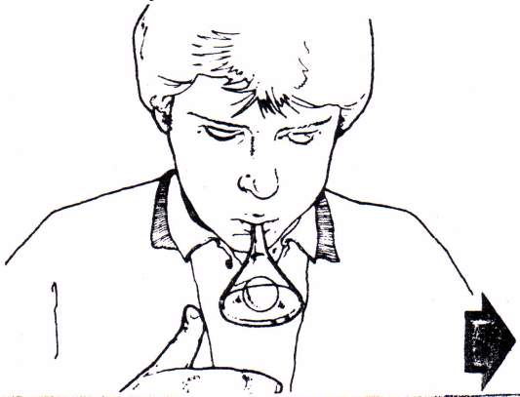
Question: What will happen to the ping-pong ball?

Materials: ping-pong ball, funnel

Predictions:

Procedures:
- Hold a ping-pong ball in an upside-down funnel.
- Blow hard into the funnel. At the same time, slowly take away your hand from the ping-pong ball.
- Record observations.

Observations:
  - What when you stopped blowing into the funnel?
  - What happened to the air in the funnel when you blew?

Conclusions:
- What is the fast moving air creating?
- What is the difference between the air on the inside of the funnel and the air on the outside of the funnel?

Appendix: 1

Activity #2:

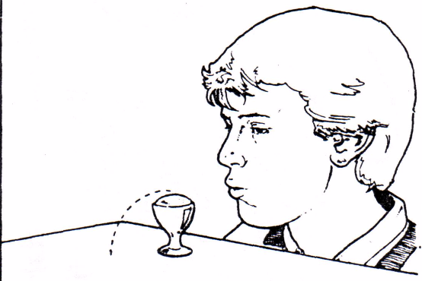
Question: What will happen to the piece of paper?

Materials: 1x sheet of paper

Predictions:

Procedures:
- Fold a sheet of paper in half and stand it upright on the table.
- Blow through the “tunnel” opening.
- Record observations.

Observations:
  - What did you observe when you were blowing underneath the card?

Conclusions:
  - What properties does stationary air have?
  - When blowing underneath the card, what is different about the air underneath the card compared to the air above the card?
  - Why do you think the card did not blow off the table?

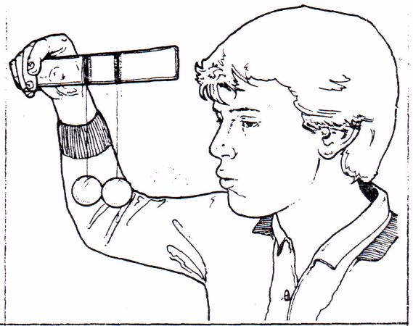
Appendix: 1
Activity #3:

Question: What will happen to the Styrofoam balls?

Materials: 2x styrofoam balls, string, tape, ruler

Predictions:

Procedures:
- Raise the ruler so that the styrofoam balls are suspended in the air; wait until the styrofoam balls are not moving.
- Blow between the two styrofoam balls.
- Record observations.

Observations:
- What did you observe when you blew between the balls?

Conclusions:
- What was created between the balls by blowing?
- What is different about the air between the two balls and the surrounding air?

Appendix: 1
Activity #4:

Question: What will happen to the ping-pong ball?

Materials: egg cup holder, ping-pong ball

Predictions:

Procedures:
- Place a ping-pong ball in the egg cup.
- Blow over the top of the egg cup.
- Record observations.

Observations:

Conclusions:

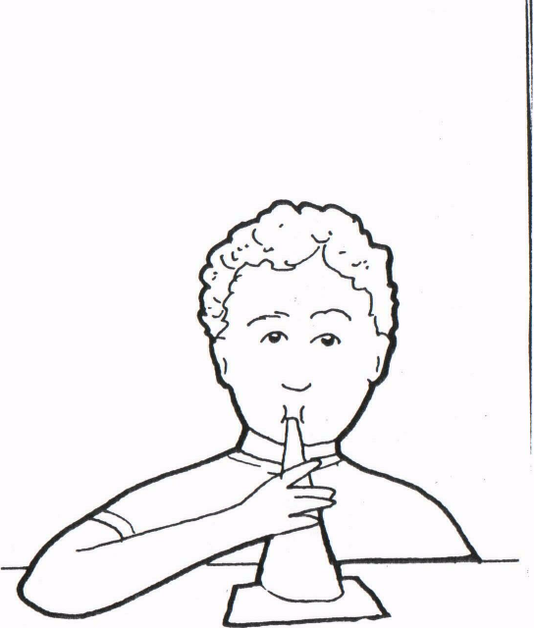
Appendix: 1

Activity #5:

Question: What will happen to the 3” x 5” card?

Materials: 3” x 5” card, funnel

Prediction:

Procedures:
- Hold the funnel with the large end down over the card.
- Suck air through the funnel.
- Record observations.

Observations:

Conclusions:

Appendix: 1
Activity #6:

Question: What will happen to the strip of paper?

Materials: strip of paper (5cm x 15cm)

Predictions:

Procedures:
- Hold the strip of paper with two hands just under your lower lip.
- Blow.
- Record observations.

Observations:
- What happened to the paper?

Conclusions:
- Why do you think the paper lifted?

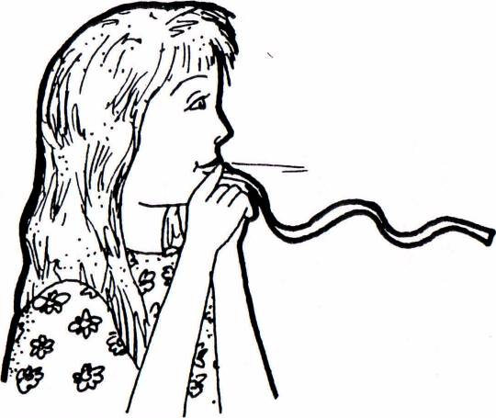
Appendix: 2

Flight: Name:_________________

Bernoulli’s Principle:

Draw a labelled diagram of one of the investigations showing Bernoulli’s Principle.

Describe what happened in this investigation. Include these words in your explanation:
air low pressure exert force
stationary moving high pressure

_______________________________________________________________________________________________________________________________________________________________________________________________________________________________________________________________________________________________________________________________________________________________________

